User Manual: My Movie Search

* Search Movie:

1. Users can search the movie by using four filters such as movie name, genre, rating, and release year.
2. Users may search movies using any combination of the above-cited filters e.g. either search via movie name or search via name and genre etc.
3. After selecting the desire filter click on the submit button 
4. The results will be shown on the next page as shown in the figure 1.

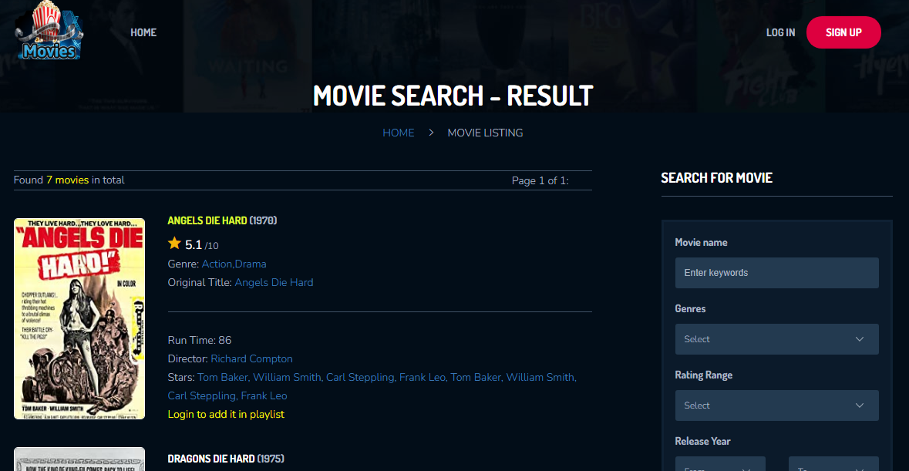

*Figure 1: Search Result*

* Sign Up:

Users need to sign up to enable the playlist options otherwise users can only search the movies only without creating an account.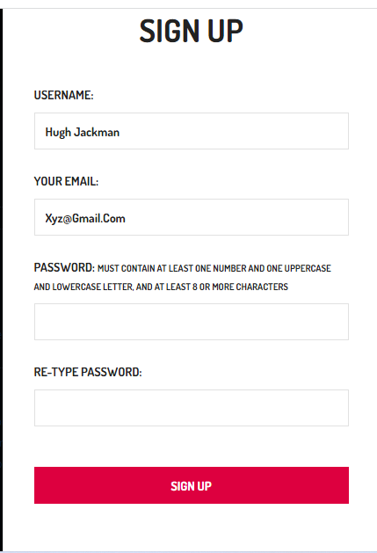

1. Click on the signup red button on the top right corner 
2. Fill the signup form with the information as shown in figure 2:
3. Enter the valid Username
4. Enter the valid Email address
5. Enter the password, which must contain at least one number and one uppercase and lowercase letter, and at least 8 or more characters.
6. Re-Type the password, if the re-type password matched with the original above password then a tick-mark symbol in green will display , in case of mismatch red cross symbol will be shown 
7. After filling the form click on the Sign Up button, on successful sign up the system will prompt the congratulation message.

* Log IN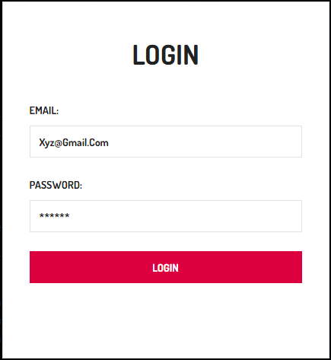

1. Click on the Log IN link, it will show the login form as depicted in figure 3:
2. Enter the valid Email address
3. Enter the valid Password
4. Click on the Login button
5. On successful login system will display 3 more menus, such as Create Playlist, View Playlist, and Log Out along with the welcome message on the top navigation bar, as shown in figure 4.



*Figure 4: Menus after Login*

* Create Playlist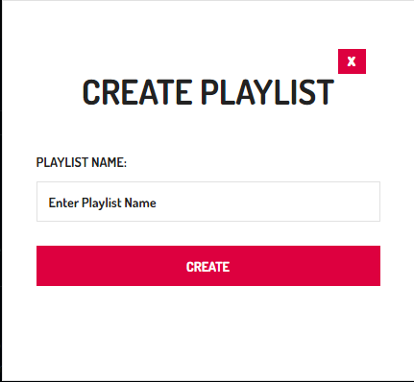

1. Click on the create playlist link, and a form will be popup as shown in figure 5.
2. Enter the valid Playlist Name and click the red CREATE button
3. The system will create a playlist against your account, now you are ready to add movies to it.

* Add a movie to the playlist

1. To add a movie to the playlist, just search for the desired movie and in the result list you will find an option against each movie 
2. Click the option, which will pop up the as shown in figure 6, select the desired playlist, and click on the ADD button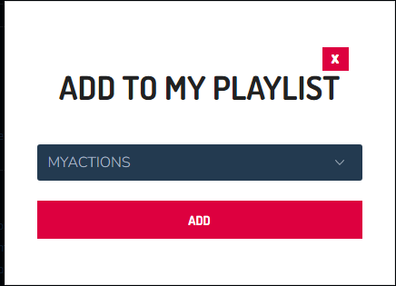
3. Once the selected movie is added to the playlist the above icon of ‘Add to Playlist’ will disappear.

* View Playlist

1. To view the movies in the playlist click on the View Playlist link on the top navigation bar.
2. The details of movies in your playlist will be displayed as depicted in figure 7.

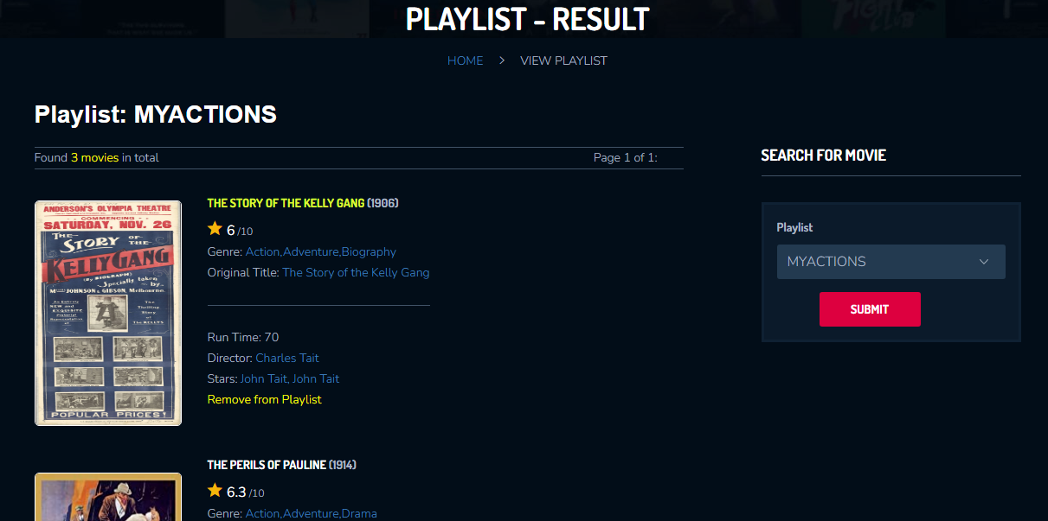

*Figure 7: View Playlist*

1. User may select a different playlist if exists from the right-side panel and click the ‘Submit’ button to see the desired playlist movies.
2. User may also remove the specific movie from the playlist by clicking on the link named as ‘Remove from Playlist’ given at the end of each movie detail.